

DEPARTMENT OF COMPUTER SCIENCE AND ENGINEERING

MINI-PROJECT STUDENT HANDBOOK

Team Members:
- P. Akaash (23881A05GM)
- R. Meenakshi (23881A05GT)
- S. Sathwik (23881A05GV)
Guide: G. ANUSHA



DEPARTMENT OF COMPUTER SCIENCE AND ENGINEERING
III B.TECH II SEMESTER
BATCH 2023-27 | MINI PROJECT  2025-26 | ACADEMIC YEAR  2025-26

TEAM ID: 23MPCS-H21
TEAM MEMBERS:
Sl.  No | Roll No | Name | Email Id | Mobile No
1 | 23881A05GM | P. Akaash | peddollaakaash@gmail.com | 7981664516
2 | 23881A05GT | R. Meenakshi | rathikindimeenakshi857@gmail.com | 9392378042
3 | 23881A05GV | S. Sathwik | sathwikteju@gmail.com | 8341461137

GUIDE DETAILS:
Name of the Guide | G. ANUSHA
Designation | Assistant Professor
Department | Computer Science and Engineering
Email Id | Anusha1843@vardhaman.org
Contact No | 7993294431
Area of Interest | Machine Learning

Signature of Guide Signature of Project Signature of HoD with Date
Coordinator

PROJECT MILESTONE TRACKER

Phase | Task | Target Date
1 | Topic Selection | 20.11.2025
2 | Background Research | 27.11.2025
3 | Define Objectives | 30.11.2025
4 | Project Planning | 02.12.2025
5 | Literature Survey | 12.12.2025
6 | Review-I | 20.12.2025-24.12.2025
7 | Design Phase | 05.01.2026
8 | Implementation | 20.01.2026
9 | Review-II | 21.01.2026-24.01.2026
10 | Testing and Evaluation | 20.02.2026-26.02.2026
11 | Documentation | 15.03.2026-27.03.2026
12 | Final Presentation | 2.04.2026

Signature of Guide Signature of Project Signature of HoD with Date
Coordinator

1. Topic Selection
How to do it:
- Think of topics that interest you — something you enjoy or are curious about.
- Check which topics are currently useful in the industry or trending.
- Ask your teachers or seniors for ideas.
- Make sure the topic is not too big (you won’t have enough time), and not too small (no learning).
- Example: Instead of doing ―AI in everything,‖ do ―AI-based face recognition attendance.‖
List of Project Titles

S No. | List of Project Titles
1 | Deep Learning–Based Pattern Verification Framework Using Modern Web Technologies
2 | Crop Disease Detection Using Deep Learning and Computer Vision
3 | Weather Forecasting & Rain Prediction using Time-Series ML
4 | Credit Card Fraud Detection Using Machine Learning
5 | Medical Image Classification for Disease Detection Using CNN
6 | Smart Irrigation System Using Machine Learning and IoT
7 | Heart Disease Prediction Using Machine Learning Algorithms
8 | Handwriting-Based Signature Identification for Secure Document Processing

Finalized Title: Real-Time Vehicle Detection and Traffic Flow Prediction

Date of Submission: 15-10-2025

Internal Guide Project Coordinator

2 Background Research
How to do it:
- Go to Google Scholar or IEEE Xplore and search your topic.
- Read articles, papers, blogs to understand what is already done.
- Write down key points: What works well? What are the problems?
- Example: If you are doing face recognition, read about different face recognition techniques (CNN, OpenCV, etc).

List of Articles Referred
S. No | Paper Title | Abstract in short
1 | Traffic signal contol optimization using genetic algorithm and vissim simulation | Traffic signal optimization provides a cost-effective solution to address increasing traffic congestion. This study compares Webster’s method, VISSIM-based optimization, and a Genetic Algorithm (GA) for optimizing signal timings at a real intersection using microsimulation. Results show that GA significantly improves performance by increasing vehicle throughput and reducing average delay compared to traditional methods. The findings highlight the effectiveness of GA in enhancing traffic flow under complex traffic conditions.
2 | Traffic Signal Optimization Based on Fuzzy Control and Differential Evolution Algorithm | This paper presents a hybrid traffic signal optimization approach combining fuzzy control with the differential evolution algorithm to effectively manage uncertainty and improve traffic flow at intersections.
3 | Smart Traffic Scheduling for Crowded Cities Road Networks | This study proposes an intelligent traffic scheduling framework that dynamically manages signal timings to reduce congestion and improve efficiency in densely populated urban road networks.
4 | Combining Static and Dynamic Models for Traffic Signal Control | This work introduces a hybrid traffic signal control strategy that integrates static planning with dynamic adaptation to enhance responsiveness under varying traffic conditions.
5 | Multi-Objective Strategies for Timing Signal Systems under Oversaturated Conditions | This research explores multi-objective optimization techniques for traffic signal timing that balance delay, queue length, and throughput in oversaturated traffic scenarios.
6 | Cross-Evaluation of Signal Timing Optimized by Various Traffic Simulation and Signal Optimization Tools | This paper conducts a comparative evaluation of traffic signal timing solutions produced by different simulation and optimization tools to assess their effectiveness.
7 | Traffic Signal Control Optimization Using Genetic Algorithm and VISSIM Simulation | This study applies a genetic algorithm in conjunction with VISSIM simulation to optimize traffic signal control and improve intersection performance.

Internal Guide Project Coordinator

Define Objectives
How to do it:
- Clearly write: "What do I want my project to achieve?" • List 3 to 5 goals.
- Example:
  - Build an app that takes face pictures.
  - Recognize faces with 90% accuracy.
  - Mark attendance automatically.

Objectives
- To implement real-time vehicle detection and classification using the YOLOv8 deep learning algorithm integrated with the OpenCV library for video processing.
- To analyze traffic parameters such as vehicle count, queue length, and density using computer vision–based algorithms.
- To optimize traffic signal timings through adaptive control logic and Q-learning reinforcement learning algorithms.
- To prioritize emergency vehicles by leveraging deep learning–based identification for efficient and responsive traffic signal control.

Internal Guide Project Coordinator

Project Planning
How to do it:
- Open Excel or make a table in your notebook.
- Write weeks/months across the top.
- For each week, write what work you will do:
o Week 1–2: Finalize topic and tools o Week 3–5: Study and design o Week 6–10: Coding o Week 11–12: Testing o Week 13: Documentation and PPT
- Make use of tools like Google Sheet, Trello, Notion to draw Gantt chart and paste it below. Gantt Chart
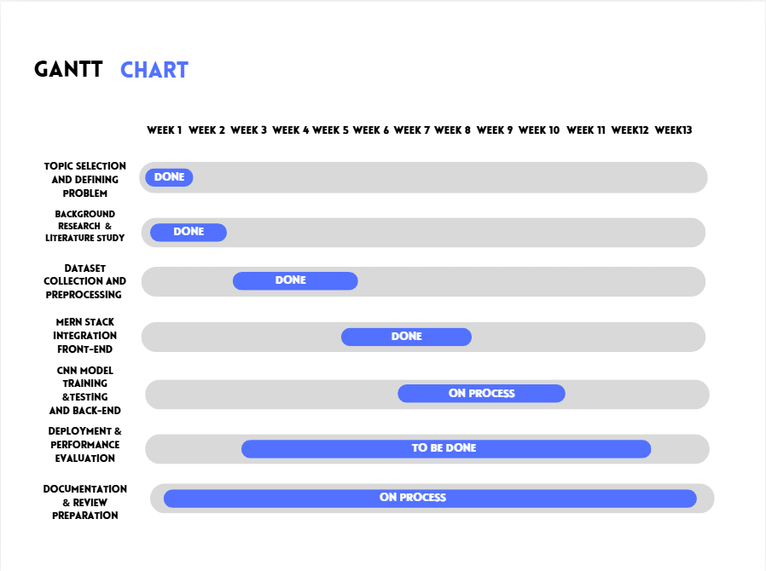

Internal Guide Project Coordinator

Literature Survey
How to do it:
- Read at least 15–20 papers.
- Write what each paper did, how they did it, and their results. • Write 1 page on ―what is missing‖ or ―how I can improve.‖
- Example: If papers used CNN, can you try a new algorithm?
Note down important points from each paper referred.
The paper focuses on optimizing fixed-time traffic signal control at a congested four-leg intersection in Gulshan-2, Dhaka, where conventional methods struggle under heterogeneous, non-lane-based traffic conditions. Using real peak-hour traffic data, a detailed microscopic simulation model was developed and calibrated in PTV VISSIM to accurately represent local traffic behavior. Three signal optimization approaches were compared: Webster’s method, VISSIM’s internal optimization, and a Genetic Algorithm (GA)–based method. Webster’s method, based on traditional traffic flow theory, showed limited effectiveness, while VISSIM optimization provided only slight performance improvements. In contrast, the GA approach optimized green time splits for a fixed cycle length using a multi-objective fitness function that maximized vehicle throughput while minimizing delay. Simulation results demonstrated that GA-based optimization achieved about 2.24% higher hourly vehicle throughput and nearly 28% reduction in average delay compared to Webster’s method. The study concludes that GA combined with microsimulation is a powerful and practical solution for improving intersection efficiency in complex urban traffic environmentsThe paper “Offline Signature Verification using DAG-CNN” introduces a DAG-CNN architecture for offline signature verification. Unlike a normal CNN, DAG-CNN uses multiple convolution paths to extract features at different levels and combine them for better classification. The paper performs writer-independent verification and includes genuine, forged, and non-member signature classes to reject unknown users. The proposed model achieves very high testing accuracy (around 99%), showing that multi-branch feature learning improves verification and forgery detection. The approach demonstrates good performance in distinguishing genuine and forged signatures. However, the experiments are conducted on a small dataset and limited registered users, which affects scalability for real-world applications.
Stevanovic et al. (2018) investigated the application of a stochastic optimization algorithm for traffic signal control and transit priority using microscopic simulation in VISSIM. The study focused on addressing uncertainties in traffic demand and transit vehicle arrivals, which are often ignored in deterministic optimization approaches. Using simulation-based experimental data, the authors demonstrated that stochastic optimization consistently outperformed deterministic methods by producing more robust and adaptable signal timing plans. Significant reductions were observed in average vehicle delay, transit delay, and overall network performance, indicating better coordination between general traffic flow and public transport priority. A key strength of the approach was its ability to handle variability and randomness inherent in real-world traffic conditions, leading to more reliable operational outcomes. However, the study was limited to simulation-based validation, involved high computational costs, and posed challenges for real-time or large-scale deployment. Additionally, the work did not explore evolutionary algorithms and remained primarily focused on transit-oriented performance rather than broader traffic optimization.
Deb et al. (2022) introduced NSGA-II, a fast and elitist multi-objective genetic algorithm designed to efficiently solve problems with conflicting objectives. The algorithm was validated using standard benchmark datasets such as ZDT and DTLZ, which are widely used to test multi-objective optimization performance. NSGA-II improved upon earlier genetic algorithms by incorporating fast non-dominated sorting, crowding distance for diversity preservation, and elitism to retain the best solutions across generations. Key findings showed that NSGA-II achieves faster convergence to the Pareto-optimal front while maintaining better diversity among solutions, making it suitable for complex multi-objective problems. Despite its strong theoretical and computational performance, the algorithm was not applied to any specific application domain, including traffic systems. The study lacked integration with simulation environments, operated in an offline optimization setting, and did not evaluate real-world performance metrics such as delay or throughput. Computational scalability for very large problems also remained a concern.
Mulandi et al. (2020) conducted a cross-evaluation study of signal timing plans optimized using different traffic simulation and signal optimization tools, including VISSIM, SYNCHRO, and TRANSYT. The study used real-world traffic network data from an urban arterial corridor, incorporating traffic volumes, intersection geometry, and existing signal plans to ensure a fair and realistic comparison. The key finding was that signal timings optimized in one tool often did not perform equally well when evaluated in another, highlighting strong tool dependency in optimization results. No single software consistently outperformed the others across all scenarios, emphasizing the importance of calibration, validation, and cross-evaluation before real-world deployment. The study revealed that optimization assumptions and internal models significantly influence performance outcomes. However, the research did not incorporate advanced metaheuristic or evolutionary algorithms, lacked uncertainty modeling, relied on offline optimization, and considered only limited control strategies, leaving scope for more adaptive and intelligent optimization frameworks.
This paper proposes a two-layer cooperative traffic control and trajectory optimization framework for intersections with mixed connected and automated vehicles (CAVs) and human-driven vehicles (HVs). The system introduces pre-signal lights and dedicated CAV lanes to reduce uncertainty caused by human driving behavior and to collect advance turning and phase information. The upper-layer model optimizes signal phase durations in real time using an improved Webster-based approach, while the lower-layer model optimizes CAV lane-changing strategies and speed trajectories to minimize delay, fuel consumption, emissions, and lane-change costs. An improved cuckoo search algorithm is used to solve the nonlinear optimization problem. Simulation results using VISSIM show significant improvements over fixed-time control, including 8–10% higher throughput, 13–18% delay reduction, and notable reductions in fuel consumption and CO₂ emissions. However, the framework assumes high CAV penetration, advanced infrastructure, and dedicated lanes, limiting immediate real-world scalability.
This paper presents a GIS-based multidimensional data-driven traffic management framework that integrates short-term traffic flow prediction with dynamic signal timing optimization. The authors propose a hybrid DTP prediction model, combining XGBoost and Multi-Layer Perceptron (MLP), optimized using differential evolution, to capture complex spatiotemporal traffic patterns. By fusing heterogeneous data sources such as road network structure, real-time traffic flow, spatial correlations, and holiday effects, the model achieves 95% prediction accuracy, outperforming single-model approaches by 19.1%. The predicted traffic flow is then used within a SCATS-based dynamic signal control system to optimize green signal allocation and regional coordination. Case studies from Nanxun Ancient Town show improved traffic balance, a 20% increase in road speed, and a 30% reduction in congestion index. However, the approach requires large-scale high-quality data, significant computational resources, and complex system integration, posing challenges for real-time urban deployment.
This study proposes a dual-layer optimization framework for traffic signal control at isolated intersections to overcome the inefficiencies of static and single-objective signal timing strategies. The upper layer employs multi-objective evolutionary optimization (NSGAII-MOPSO) to minimize vehicle delay, number of stops, and fuel consumption, while the lower layer uses a fuzzy neural network (ANFIS) to dynamically adjust green signal durations based on real-time queue length variations. Simulation experiments using SUMO and real traffic data reveal significant performance gains, achieving 11.1%–29.0% reduction in average delay compared to Webster and actuated control methods. The framework demonstrates strong adaptability to fluctuating traffic demand. Despite its effectiveness, the model is computationally intensive, focuses only on isolated intersections, and requires advanced sensing infrastructure, limiting its practicality for large-scale real-time deployment without further simplification.
This paper addresses the limitations of conventional fixed-time traffic signal systems by proposing a fuzzy logic–based adaptive traffic signal control framework capable of responding to real-time traffic conditions. The system uses traffic flow parameters such as vehicle speed, traffic density, and road occupancy as fuzzy inputs and applies a rule-based inference mechanism to dynamically adjust signal timings. Simulation experiments conducted using SUMO demonstrate notable improvements in traffic performance, including reduced average waiting time, lower congestion levels, improved throughput, and enhanced pedestrian safety when compared to fixed-time controllers. The fuzzy controller proves effective under varying traffic conditions and is relatively simple to implement. However, the approach heavily depends on expert-defined fuzzy rules, making scalability and adaptability challenging for large urban networks. Additionally, the system lacks learning capability, which limits its robustness under extreme or unexpected traffic scenarios, highlighting the need for hybrid or learning-based extensions.

This paper proposes a dynamic traffic signal optimization framework based on the Snake Optimizer (SO), a bio-inspired metaheuristic algorithm, integrated with the SUMO traffic simulation environment. Real traffic data from Algiers city are used to model realistic urban traffic scenarios involving multiple intersections. The Snake Optimizer dynamically adjusts green signal durations by balancing exploration and exploitation, aiming to minimize average vehicle waiting time, travel time, and CO₂ emissions. Simulation results show that the SO-based approach consistently outperforms static signal control and ACO-DSOS methods, achieving lower congestion levels and higher traffic throughput. Despite its strong performance, the study relies on simulation-based evaluation, uses predefined cycle programs, and requires further validation for real-time, large-scale deployment in smart city environments.
This paper proposes deep reinforcement learning (DRL)–based traffic signal control methods to optimize traffic flow at signalized urban intersections. A custom lightweight simulation environment, compatible with OpenAI Gym, is developed to reduce computational cost while enabling flexible experimentation. The study compares Deep Q-Network (DQN) and Proximal Policy Optimization (PPO) algorithms using both discrete and continuous action spaces, where agents control either traffic light phases or their durations. Performance is evaluated using average waiting time (AWT) and average queue length (AQL) as reward metrics, along with penalties for traffic rule violations. Experimental results show that PPO provides more stable learning, avoids catastrophic forgetting observed in DQN, and achieves lower delays and queue lengths, especially when using continuous phase duration control. The study highlights the importance of reward design and action space selection. However, the work is limited to single-intersection simulation, excludes pedestrians and coordinated networks, and requires further validation for real-world deployment.

Internal Guide Project Coordinator

6. Design Phase
How to do it:
- Draw simple diagrams:
  - Block Diagram: How system works in blocks. o Flowchart: Step by step how the process flows. o Use tools like StarUML to draw UML Diagrams – Use Case Diagram, Class Diagram Sequence diagram, Activity Diagram – and paste below.
- Decide tools:
  - Will you use Python? o Which library? (TensorFlow, OpenCV?) o Where to store data? (SQLite?)

Project Architecture
The flow diagram illustrates the real-time working of the adaptive traffic signal optimization system. Traffic cameras continuously capture live video, which is processed and analyzed using OpenCV and YOLOv8 to detect vehicles and estimate traffic density. Based on the analyzed traffic parameters and emergency vehicle detection, the decision engine computes optimal signal timings. The traffic signal controller then dynamically updates signal phases to improve traffic flow and reduce congestion.
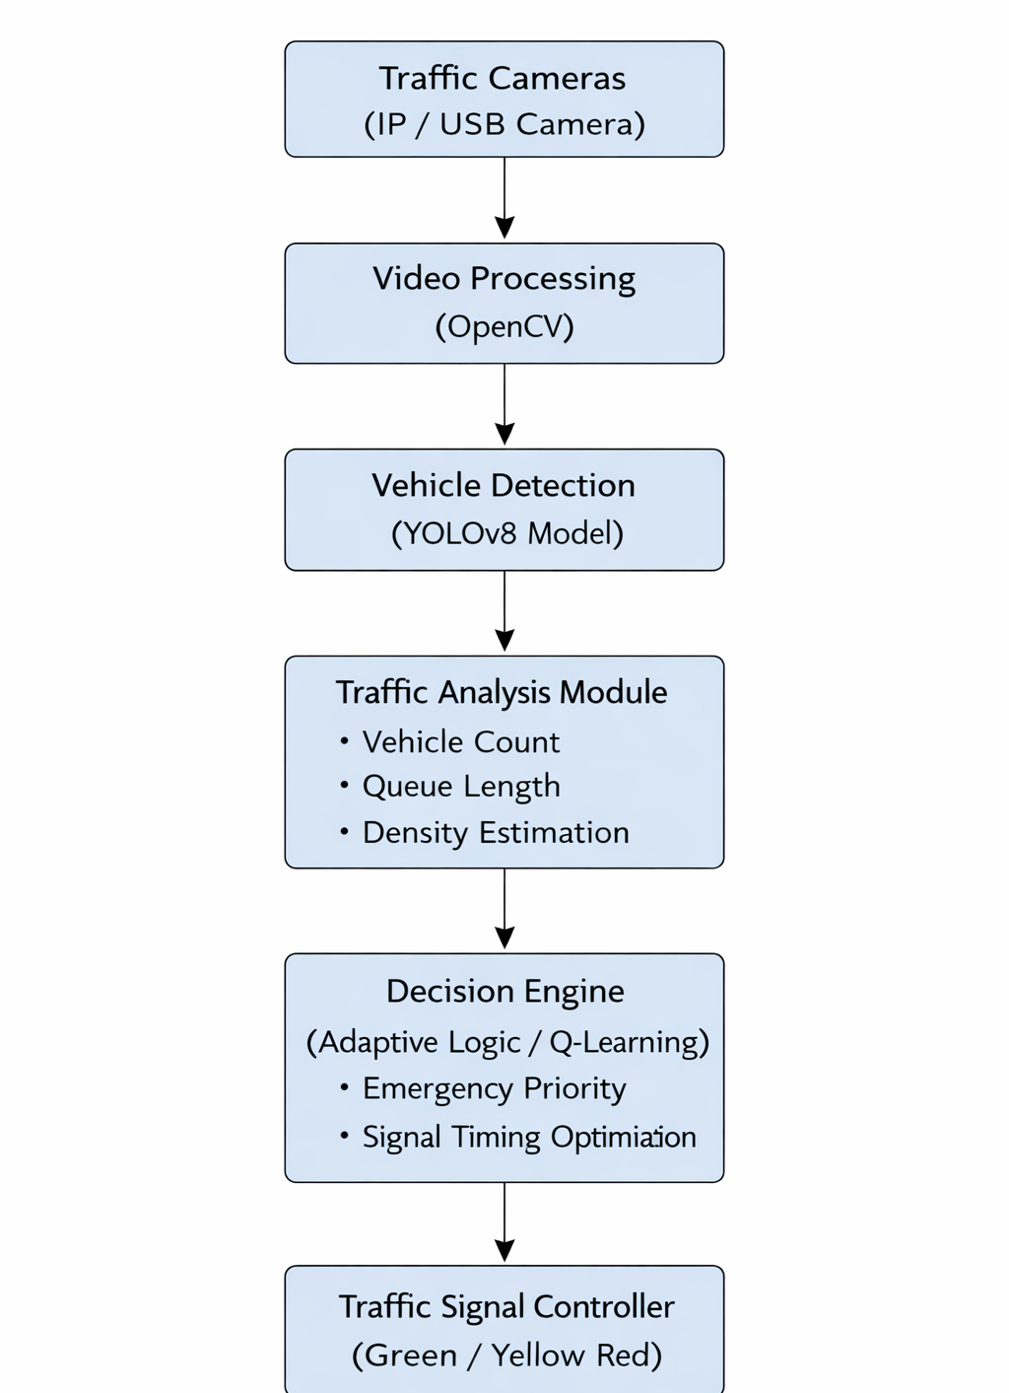

Use Case Diagram
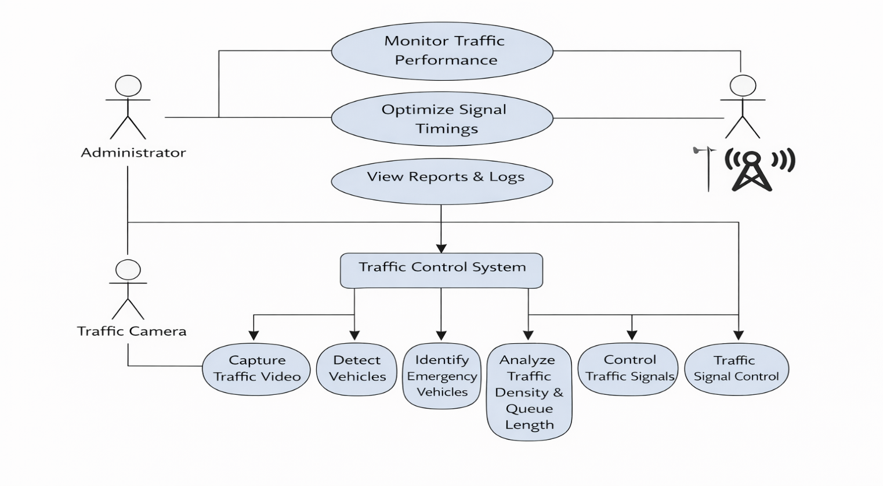

Class Diagram
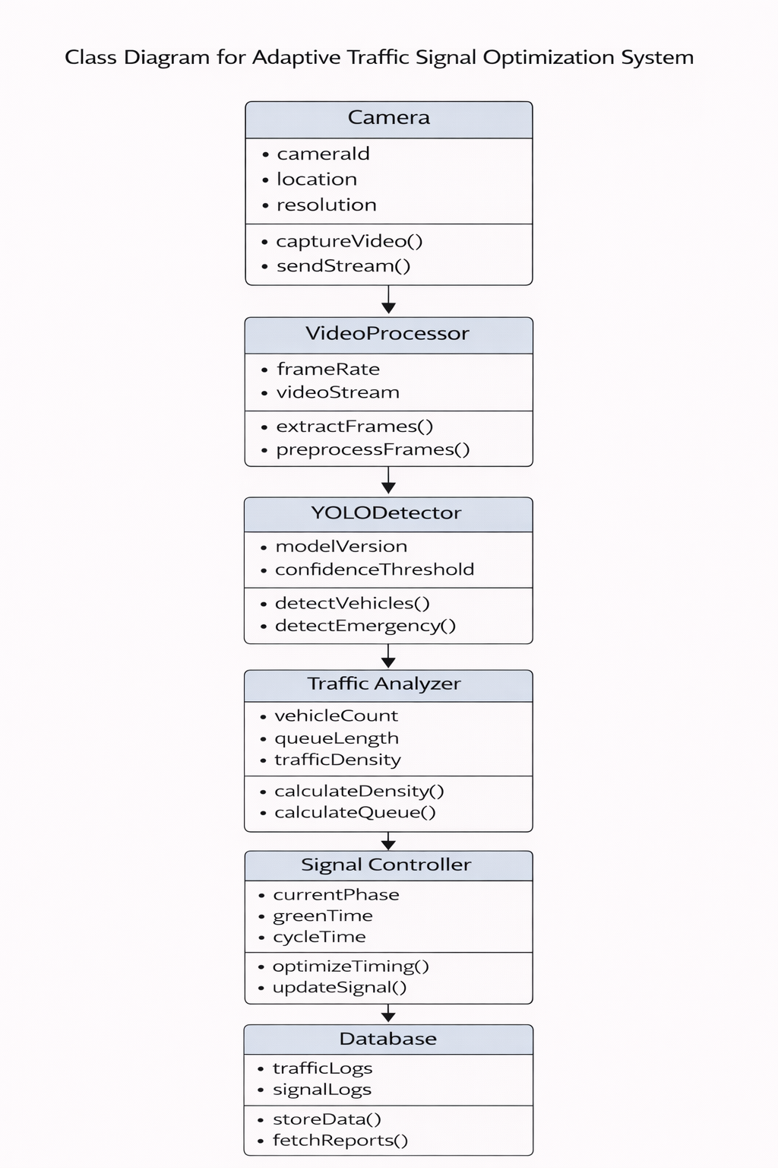

Sequence Diagram
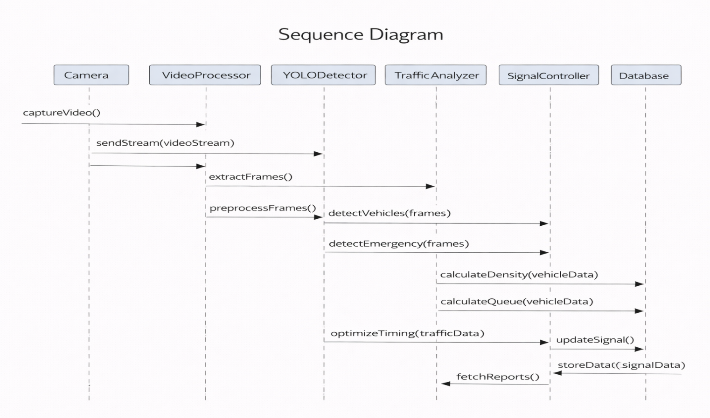

Activity Diagram
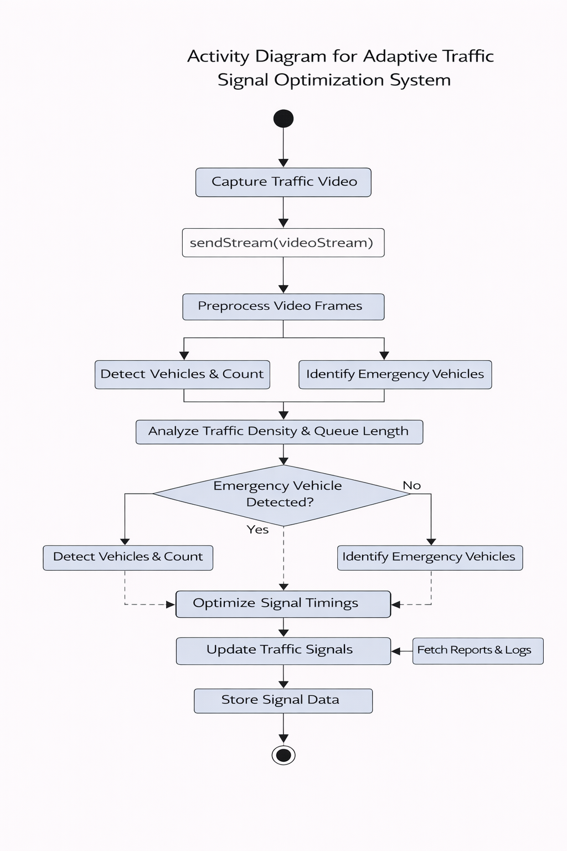

List of Tools to be used for implementation

Software Requirements
- Framework: Flask (Python) – for developing the backend and handling server-side logic
- Frontend: HTML, CSS – for designing the user interface and web pages
- Libraries:
  - OpenCV – for image and video processing
  - YOLOv8 – for real-time vehicle detection and emergency vehicle identification
  - OS – for system-level operations
  - Time – for managing time-based processing and delays
  - Flask – for routing and web application handling

- Development Tools:
  - Visual Studio Code – for code development, debugging, and project management
Hardware and System Requirements
- Processor: Intel Core i3 (7th generation or equivalent)
- RAM: Minimum 4 GB (8 GB recommended for improved performance)
- Storage: At least 100 MB of free disk space for project files and required dependencies
- Cameras: 1080p resolution IP cameras or USB webcams for real-time traffic monitoring
- Operating System: Windows 10/11, macOS (version 10.15 or higher), or any Linux distribution (such as Ubuntu or Fedora) that supports Python development

Internal Guide Project Coordinator

Implementation
How to do it:
- Start coding simple parts first (don’t wait for full design).
- Use GitHub or save versions of your work.
- If something doesn’t work — google the error, ask your teacher, or use forums like StackOverflow, GitHub, Dev.to, Reddit.
- Test small parts (modules) before joining everything.
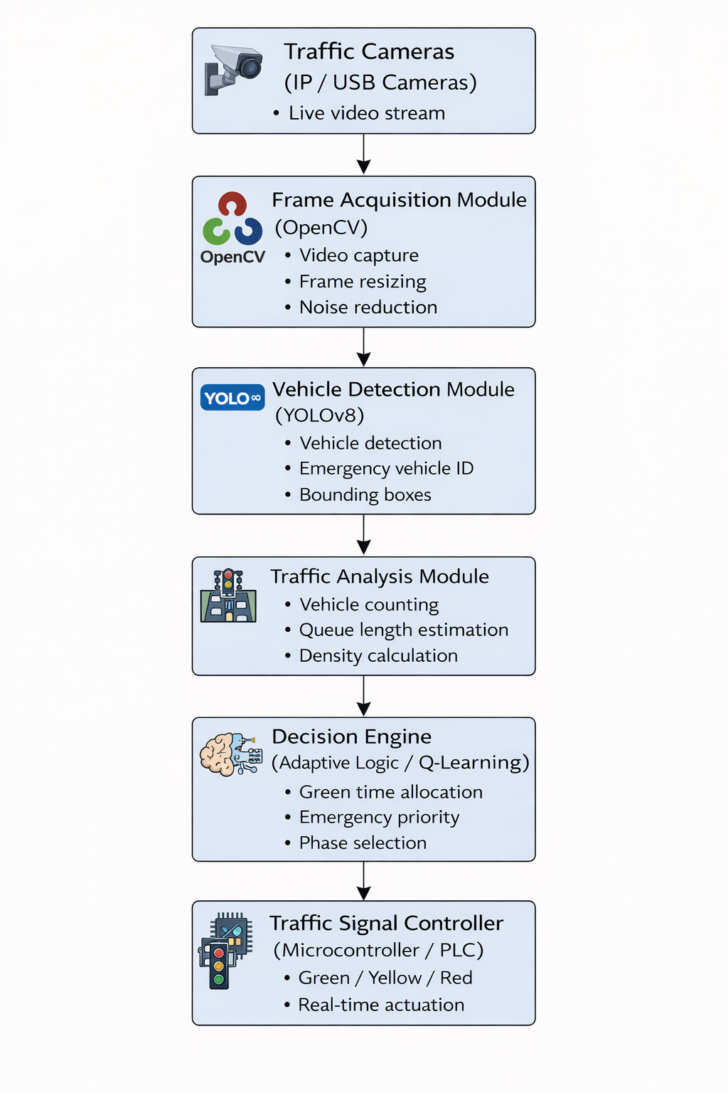

Internal Guide Project Coordinator

Testing and Evaluation

List of Test Cases :
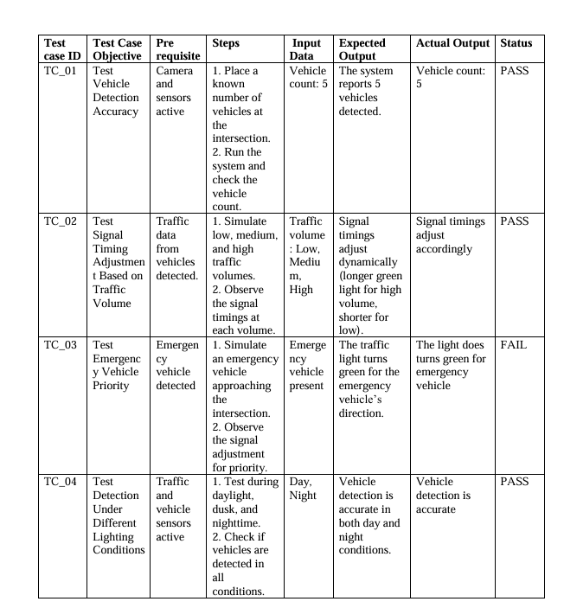

Internal Guide Project Coordinator

Documentation
How to do it:
- Use Latex for preparing Project Report as per the College Format. Format will be shared by Project Coordinator.
- Write each section step-by-step:
  - Abstract: What is your project? o Intro: Why did you choose this topic? o Literature Survey: What is already done? o Methodology: How you did your project? o Results: What did you achieve? o Conclusion: What did you learn? o References: List of papers/books you used.
  - Plagiarism Report

Internal Guide Project Coordinator

 | Internal Guide |  | Project Coordinator

